**IMChain team attended Global Seminar Blockchain Technology and Application**

24th March 2018, Global Seminar Blockchain Technology and Application was successfully held in Singapore, which was an international summit with high content and comprehensive information. Ms. Bernice Fan, CEO of IM Chain, was invited to the conference. The summit specially invited many experts in the blockchain industry to jointly interpret the application scenarios and international trend of block chain technology, and the purpose is to jointly explore and seek actual landing of application scenarios also promote the development of global blockchain technology.

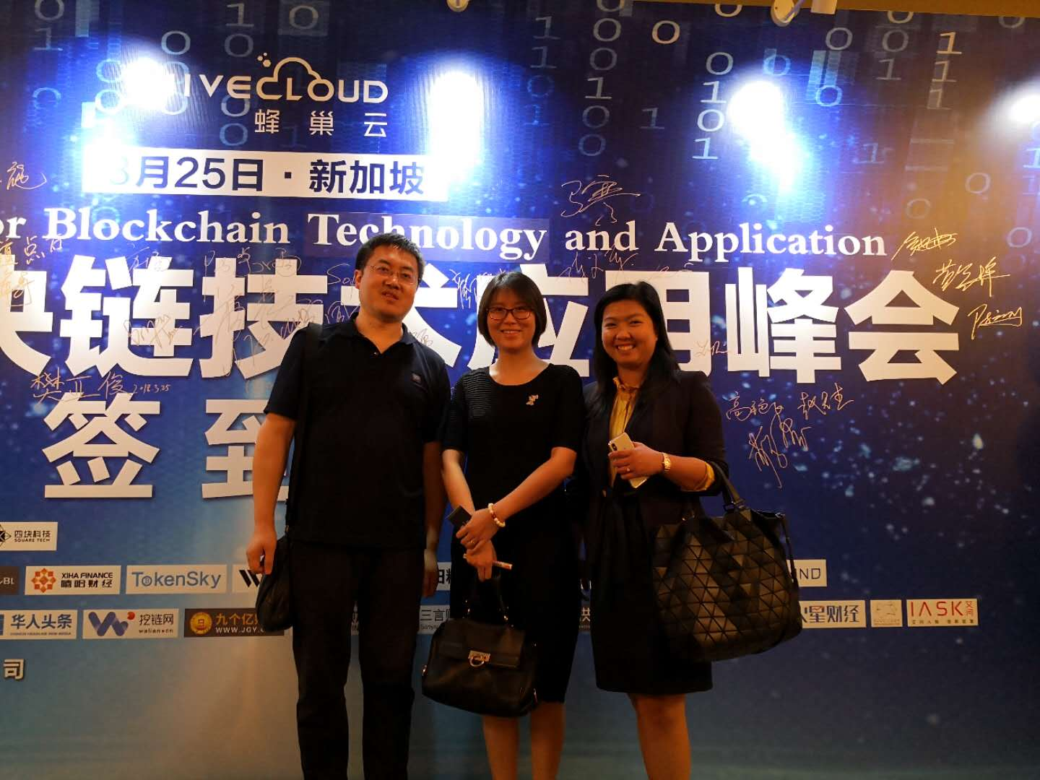

After the conference, Ms. Fan communicated and exchanged the recent progress of the project to Mr. Charles Xue, CEO of Manzi Funds, and discussed the future development of IM Chain. The progress of this project was highly praised by Mr. Xue and represents that will continues to integrates resources to promote the progress of IM Chain.

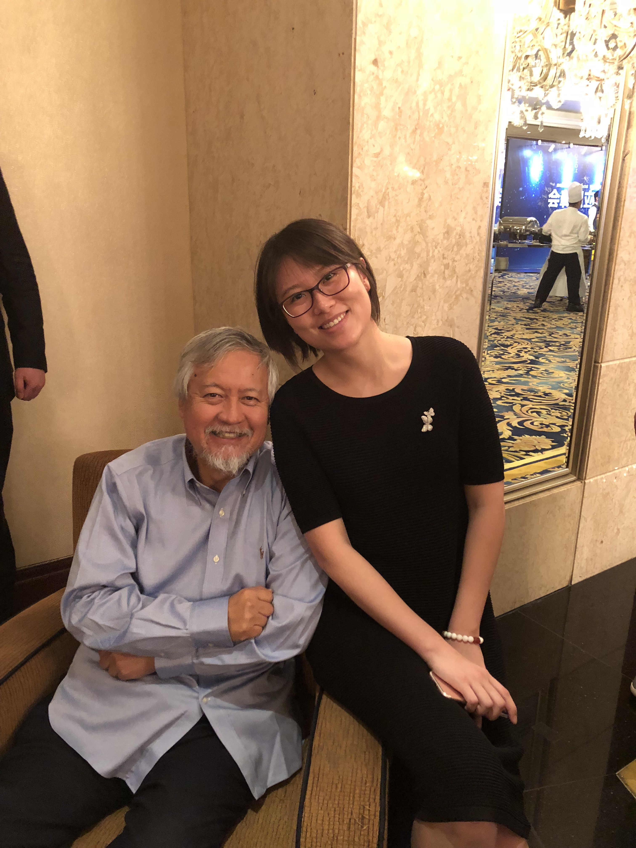

IM Chain builds a C2C, B2C, B2B e-trading cloud ecological platform which combining intelligent manufacturing and blockchain deeply, to make manufacturing capacity online publishing, manufacture resource elasticity supplying, supply and demand information docking in time, ability transaction accurate charging, to promote the optimal allocation of resources, ensure the safety of the docking and trading between supply and demand sides.

IMChain dedicate to build a resource sharing intelligent manufacturing ecological system within global by using blockchain technology, and create your own personalized super factory.